Use the sin rule to determine all sides of the triangles a) to f)  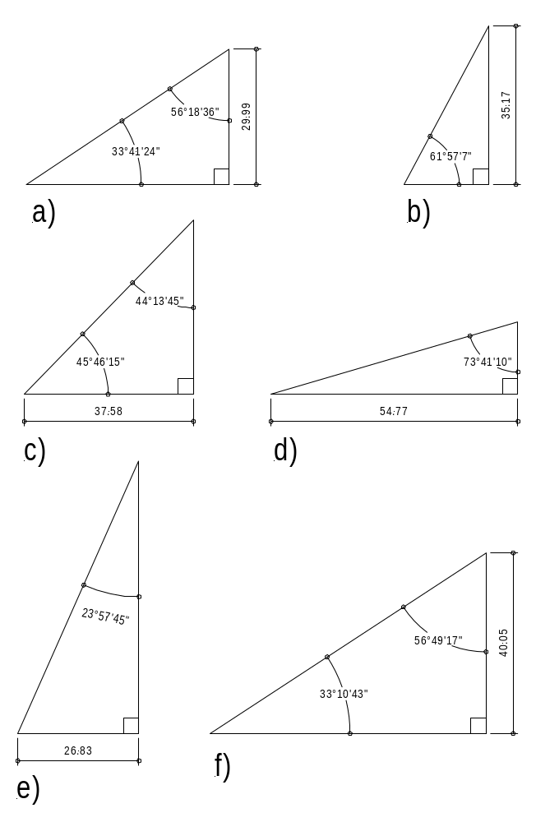 | 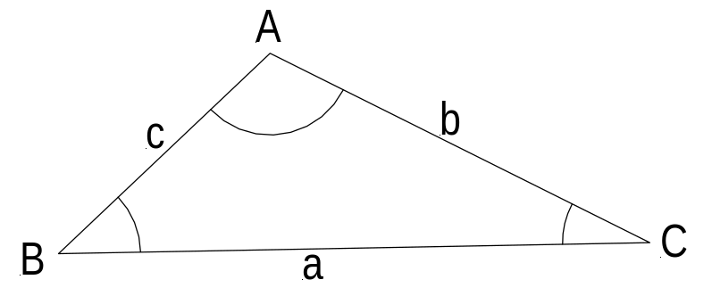  SineRule  sin A : sin B : sin C = a : b : c 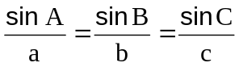  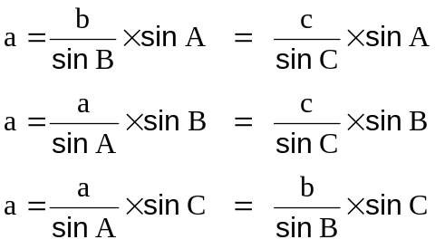  Cosine Rule  a² = b² + c² - 2 b c cos A  b² = c² + a² - 2 a c cos B  c² = a² + b² - 2 a b cos C  Area of a scalene triangle  √ s (s-a)(s-b)(s-c)  s = (a + b + c)/2

